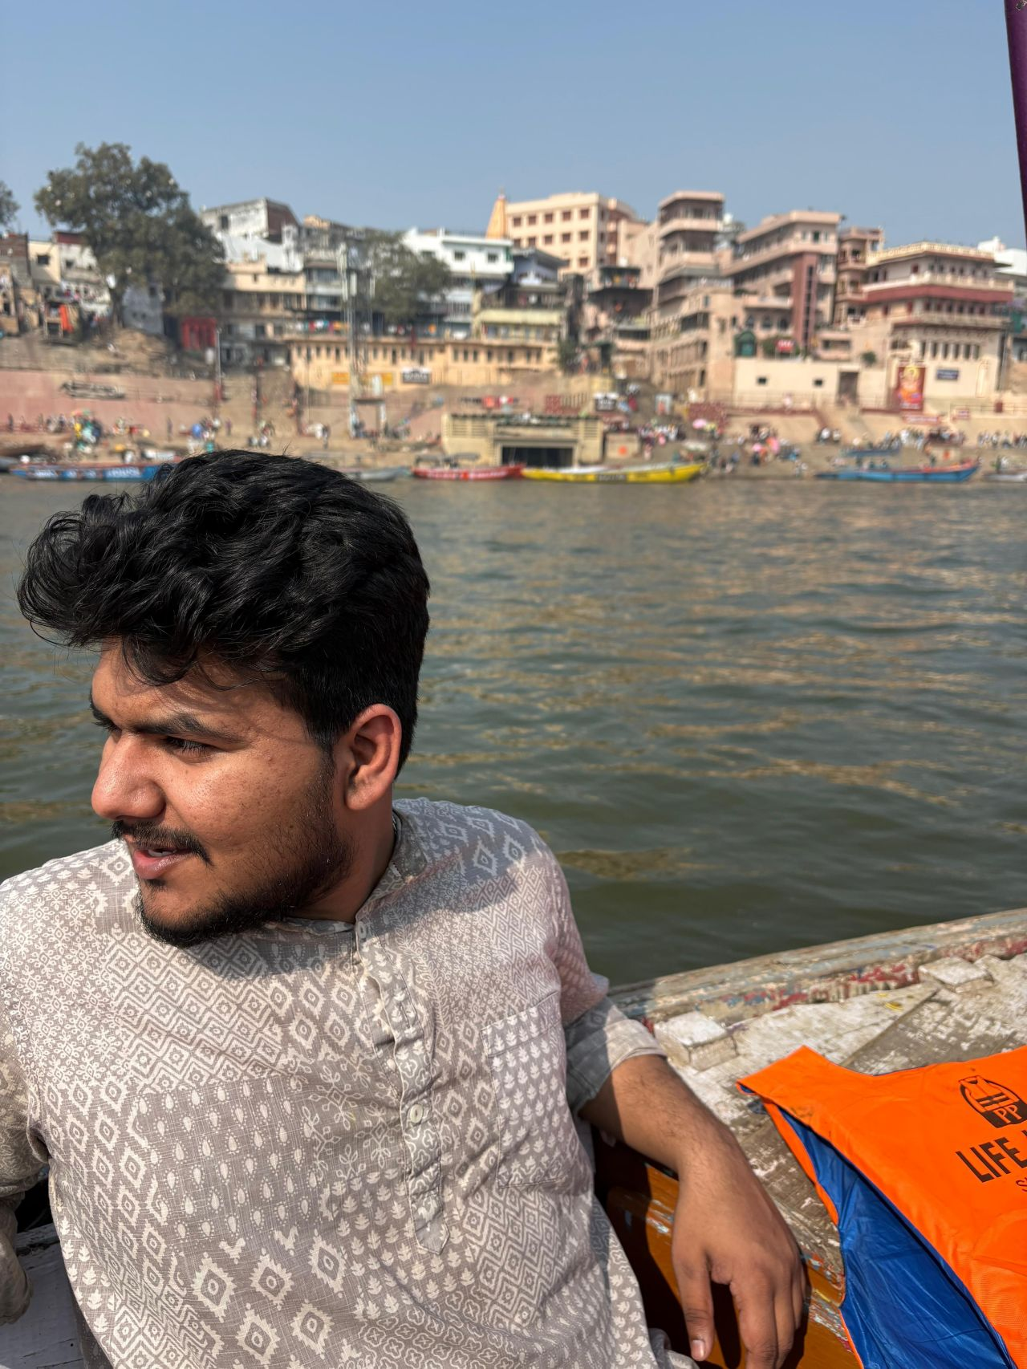

My January started in remote villages of Bihar and ended at a Linkin Park concert in Bengaluru—showing me the many meanings of being an Indian citizen.

First, this is a country that is seeing its "firsts" at scales not experienced before. First intercaste marriages to destination weddings. Chachis and Ajjas leaving their villages and states for the first time.

Data suggests a social movement has arrived. Field taught me that class can, to some extent, cushion the consequences of caste, and financial capital can counter social capital.
You still hear casteist slurs from people leaving government offices when their tenders don’t get approved.

There are other firsts. Sending one's daughter to a different city or state for higher education has gone on for about 25 years now.
What’s new is sending daughters out right after std 10 for UPSC, BPSC, or IIT/JEE coaching in tier-2 cities like Patna and Ranchi.

Educating daughters was to find better grooms.
You could still only "dream" through sons. There's a change now. Girls have outperformed boys academically for over a decade.

I learnt we have begun to dream through our daughters, but we don't yet know how to be comfortable with them chasing theirs.

I met a 21-year-old on a 2-platform station that has just 1 local train crossing it in a day. A driver by profession, he wanted me to fix his Google dialer. A UX change moved the contact list two clicks away—it disappeared.

He gave me his phone- privacy? security? It did not matter.
I was wearing glasses, wasn't chewing gutka, had a pen in my pocket; obviously, I could be trusted.

I tried downloading a different dialer app, it was filled with ads.
He knew "paisa kat jaata hai".

Being scammed by a person is better than being scammed by an app.

A person can be held by the collar at least.

He had been driving since he was 14.
People were scared of giving him their vehicle.
He was the local "pagla".

Then the Pagla fell in love. He was 19. At 20, he married, found factory work, and repaid a 2-lakh marriage loan with 1-lakh interest. He was proud of the “lift-wala” stage at his wedding.

For 2 years, he's been trying for a baby, and has already spent 70k on treatments. He believes he's in trouble because he lost his wedding ring. Somebody must have done black magic.

I learnt that age is not a number, it is a role.

I met a first-year nursing student from Chappra, to whom Patna felt like Mumbai - he wanted to travel the world.

I finally then met the 14-year-old me, blasting In the end in his bathroom before school, downloaded from songsPk, who could only dream of sharing the same air as the band.

Living that dream- in a different city, in a different life.

The Indian story is less about millennials, boomers, or the GenZ.
It is about the pace at which our dreams, fears, and hopes have grown- or become limited.
That is a function of where you are and what your role is.
It depends on the India you live in as a citizen.

Happy Republic Day. :)

